Vision Zero Prince George’s Crash Data Storymap User Guide
Web Link: https://arcg.is/0yDSO5
Description and Purpose
Vision Zero Prince George’s is a data-driven strategy to eliminate traffic-related serious injuries and fatalities. The Vision Zero Prince George’s Crash Data Storymap shows where crashes, serious injuries, and fatalities have occurred in Prince George’s County between 2015 – 2019. The storymap can be used to determine which locations tend to have a high frequency of severe crashes, and it assists the county in traffic safety planning efforts.
The storymap shows three separate dashboards of crash data.
- Fatal Crashes by Mode Type (driving, walking, or biking)
- Pedestrian Serious Injuries and Fatalities
- Fatal Crashes by Light Condition
The navigation bar at the top of the page can be used to quickly go to the dashboard that you are interested in viewing.
The data for all the dashboards is sourced from the Maryland State Highway Administration.
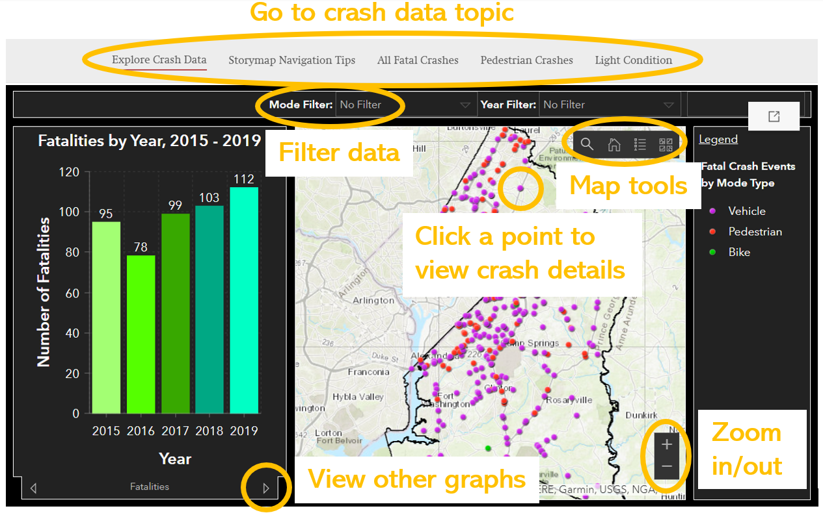
Features
Each of the three dashboards contain a map, a legend, graphs, and data filters.
- Navigating the map
You can view different parts of the map by clicking and dragging along any part of the map.
You can zoom in and out using the mouse wheel within the map, or by using the + and – icons on the screen.
If you are ever lost on the map, you can always return to the default view by clicking on the house icon.
You can also search a location by clicking on the magnifying glass in the map.

- View crash information
You can view more detailed information about each crash by clicking on a point within the map. This brings up a panel that shows the crash location, date, number of people killed and other conditions of the crash.

- Using filters
You can use various preconfigured filters to select what kind of data is displayed on the map. The filters are located at the top of each dashboard.

- Viewing graphs
You can select which kind of graph is displayed by clicking on the tabs below the graph display.

Reference Guide
If you are ever unsure about how to use the Vision Zero Prince George’s Crash Data Storymap you can click on Storymap Navigation Tips at the top of the screen to view a guide.
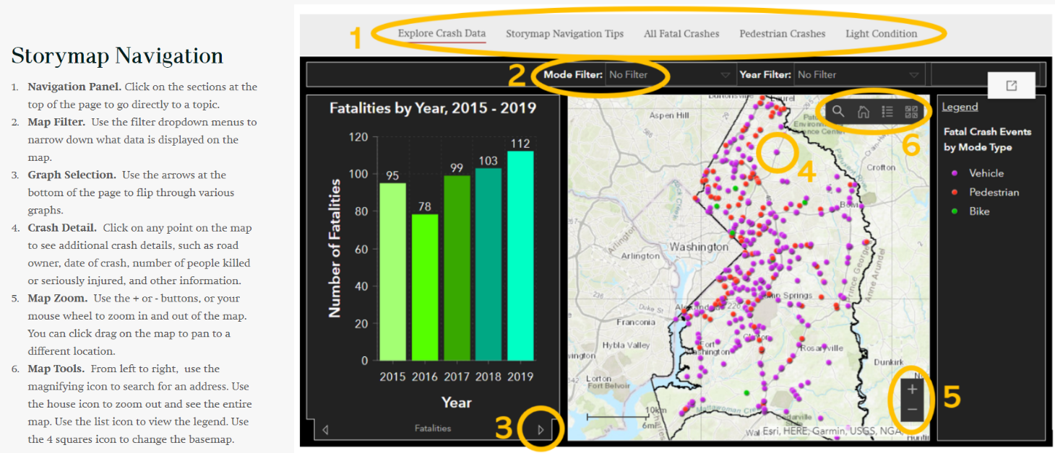

Learn more about Vision Zero Prince George’s by visiting www.visionzeroprincegeorges.com
Updated 4/9/2021

